**FOOD ORDERING SYSTEM**

**QUESTION:**

Draw a UML diagram for a food ordering system Systems. The activities of the food ordering system are listed below. Receive the Customer food orders, Produce the customer ordered food, Serve the customer with their ordered food, collect payment from Customers, Store customer payment details, Order Raw Materials for food products, Pay for Raw Materials and Pay for Labour.

**AIM:**

To design and create a UML activity diagram for a food ordering system using Umbrello software that represents the system's activities step by step.

**PROCEDURE:**

1. Open Umbrello and create a new activity diagram.

2. Add the **Initial State** symbol.

3. Add activities:

* Receive Customer Food Orders
* Produce Ordered Food
* Serve Food
* Collect Payment
* Store Payment Details
* Order Raw Materials
* Pay for Raw Materials
* Pay for Labour

4. Connect activities with **Control Flow** arrows.

5. Add the **Final State** symbol and link it to the last activity.

**DIAGRAM:**

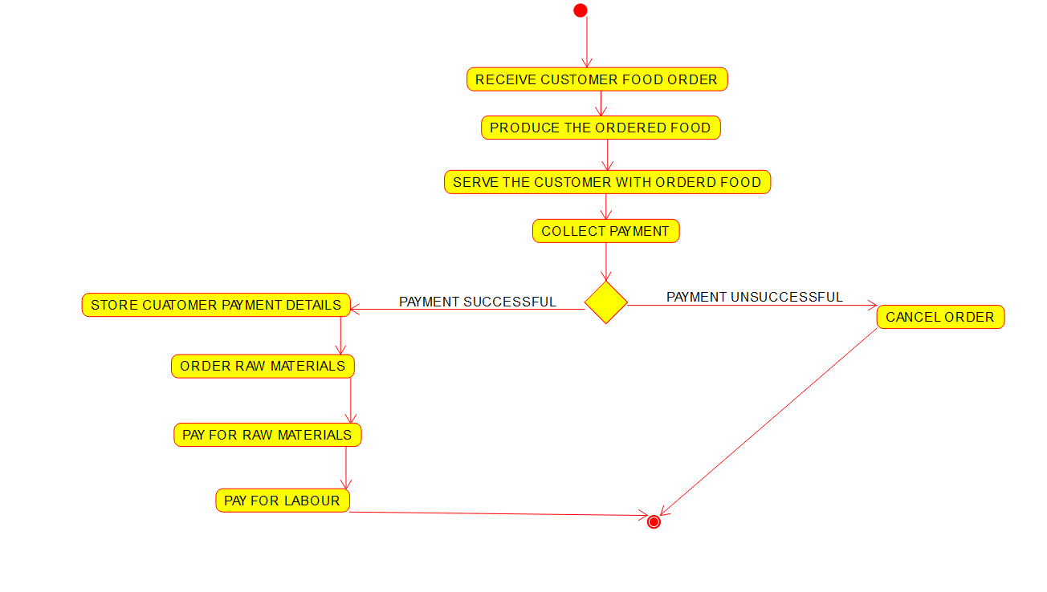

**RESULT:**

A UML activity diagram for the food ordering system was successfully created.